Dox – Evaluation Dataset and Results
- Example 1:
  - User Question: How do you log into Azure using device code authentication?
  - Bot Answer:
To log into Azure using device code authentication, you can use the Azure CLI command with the --use-device-code option. This method is useful when you cannot use a browser on the device where you want to authenticate.
Here are the steps:
- Open your terminal or command prompt.
- Run the following command:
- az login --use-device-code
- The CLI will display a device code and a URL (https://microsoft.com/devicelogin).
- On any device with a web browser, go to the provided URL.
- Enter the device code shown in your terminal.
- Sign in with your Azure account credentials.
- Once authenticated, the CLI will complete the login process and display the subscriptions associated with your account.
This process allows you to authenticate securely without needing to open a browser on the machine running the CLI.
Source: https://media.datacamp.com/legacy/image/upload/v1719844709/Marketing/Blog/Azure_CLI_Cheat_Sheet.pdf
  - Snapshot:
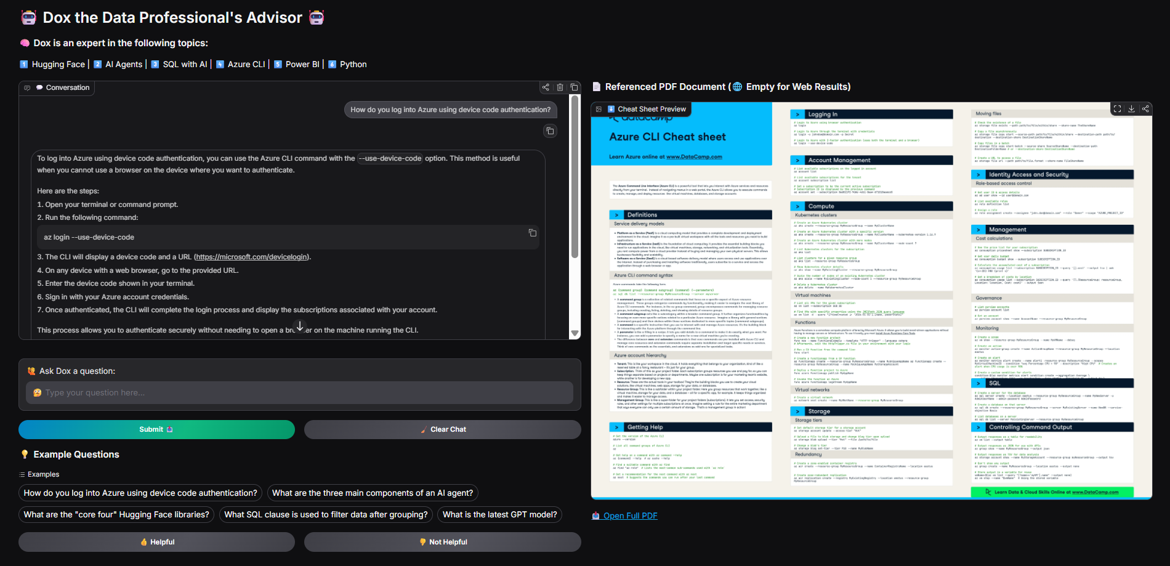

- Example 2:
  - User Question: How do you log into Azure using device code authentication?
  - Bot Answer:
The three main components of an AI agent are:
- Language Model (LM): This is the core reasoning and decision-making engine of the AI agent. It is an artificial intelligence program designed to understand, generate, and process human language. The language model powers the agent's reasoning and decision-making capabilities.
- Tools: These are external systems or APIs that the AI agent uses to interact with the outside world and gather information. Tools can include extensions, functions, and data stores that allow the agent to perform actions such as querying APIs, running code, or retrieving information from databases or documents.
- Orchestration Layer: This layer governs how the AI agent processes information, reasons, plans, and executes actions to achieve its goals. It manages the agent's memory, state, reasoning, and planning. The orchestration layer uses various cognitive architectures and prompt engineering frameworks to guide the agent's behavior.
Together, these components enable an AI agent to interact with its environment, reason about tasks, and execute actions to fulfill user-defined goals.
Source: https://media.datacamp.com/cms/ai-agents-cheat-sheet.pdf
  - Snapshot:
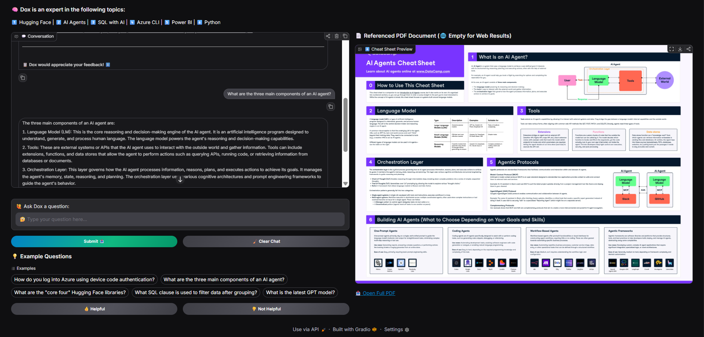

- Example 3:
  - User Question: What are the "core four" Hugging Face libraries?
  - Bot Answer:
The "core four" Hugging Face libraries are:
- transformers - This library provides models and pipelines for running inference, training, and sharing pretrained models mainly for natural language processing tasks.
- tokenizers - This library offers fast tokenization tools that convert raw text into tokens suitable for model input.
- datasets - This library is for data loading and processing, providing an Arrow-backed collection of datasets with train/validation/test splits.
- huggingface_hub - This library facilitates interaction with the Hugging Face Hub, including versioning, saving, loading, and sharing models, datasets, and spaces.
Together, these libraries form the core ecosystem for discovering, running, training, and sharing machine learning models and datasets with a strong emphasis on open-source and reproducibility.
Source: https://media.datacamp.com/cms/working-with-hugging-face.pdf
  - Snapshot: 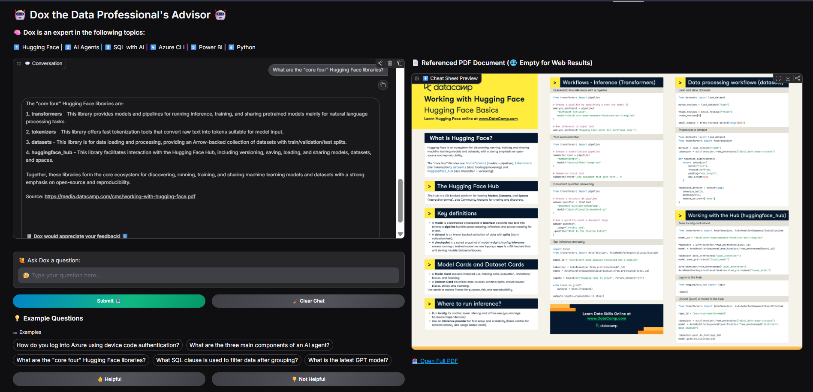

- Example 4:
  - User Question: What SQL clause is used to filter data after grouping?
  - Bot Answer:
The SQL clause used to filter data after grouping is the HAVING clause.
Explanation:
- The WHERE clause filters rows before grouping.
- The HAVING clause filters groups after the GROUP BY operation has been applied.
- HAVING is used to specify conditions on aggregate functions or grouped data.
Example:
SELECT era, AVG(pages) AS average_pages
FROM asoiaf_books
GROUP BY era
HAVING AVG(pages) > 800;
This query groups books by era and filters to show only those groups where the average number of pages is greater than 800.
Source: https://media.datacamp.com/cms/introduction-to-sql-with-ai-1.pdf
  - Snapshot:
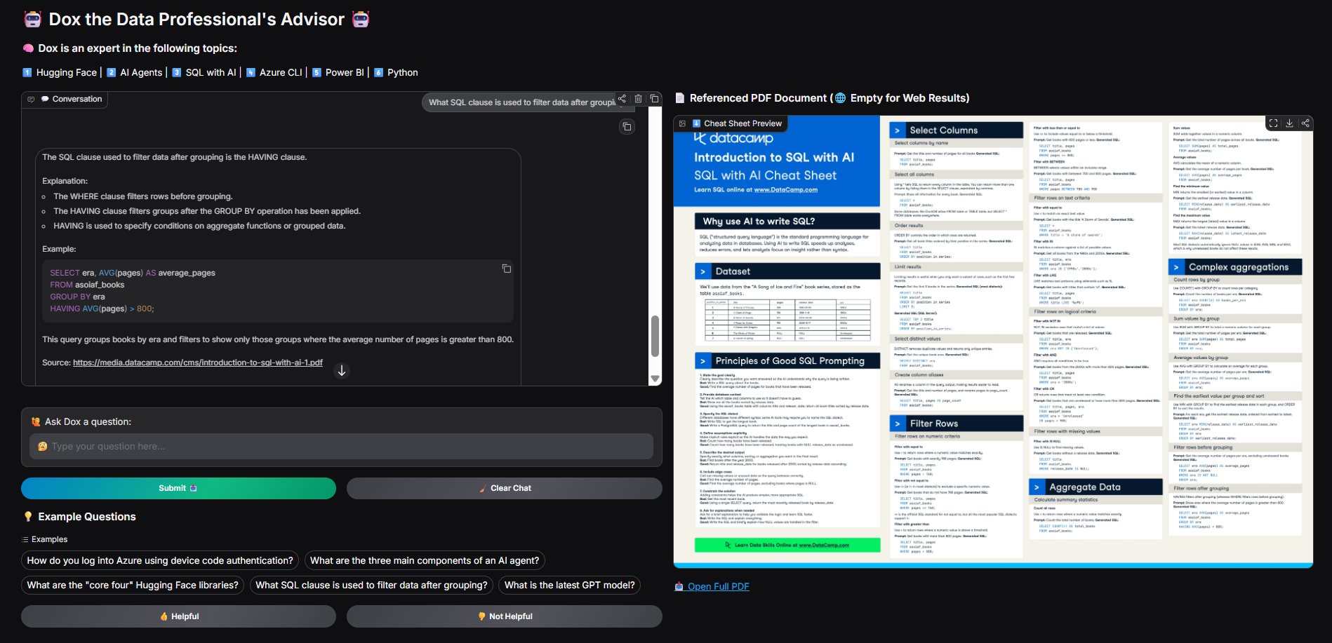

- Example 5:
  - User Question: What is the latest GPT model?
  - Bot Answer:
The latest GPT model is GPT-5.5, which was announced by OpenAI recently. This model is reported to have improved capabilities in coding, computer usage, and deeper research tasks compared to previous versions.
Prior to GPT-5.5, GPT-5.4 was released on March 5, 2026, featuring advanced reasoning, coding, and agentic workflows, integrating improvements across tools, software environments, and professional tasks.
For the most current and detailed information, you can refer to OpenAI's announcement and related news articles.
Online Source: https://www.cnbc.com/2026/04/23/openai-announces-latest-artificial-intelligence-model.html
Online Source: https://openai.com/index/introducing-gpt-5-4/
Online Source: https://en.wikipedia.org/wiki/GPT-5.4
  - Snapshot: 